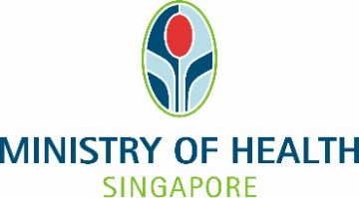
Annex A

CERTIFICATION OF MEDICAL INELIGIBILITY FOR ALL COVID-19 VACCINES UNDER THE NATIONAL VACCINATION PROGRAMME
Full Name
(as per NRIC/FIN/Passport):
NRIC/FIN/Passport Number:
Contact Number

To whom it may concern,

This is to certify that the above-mentioned person is medically ineligible for all COVID-19 vaccines under the National Vaccination Programme (NVP) because he/she is a:

(Please tick where appropriate)

Person aged 18 years (based on date of birth) and above who was unable to complete the vaccination regime due to previous severe adverse reactions or allergies# to all NVP vaccines, that currently includes both of the following (1) any mRNA COVID-19 vaccines and (2) Sinovac-CoronaVac COVID-19 vaccine; or

Person 12 to 17 years of age who was unable to complete the vaccination regime due to a previous severe adverse reaction or allergy# to a previous dose of a mRNA COVID-19 vaccine; or

Person with/ under the following condition(s)/ treatment:

Transplant within past 3 months; and/or

Aggressive immunotherapy; and/or

Active cancer on treatment*.

Please indicate the date when the above criteria will cease, inclusive of an additional two-month period where the person is fit for vaccination: ____________

# Includes those in which a person has not taken previous doses of COVID-19 vaccines but had an established allergic reaction to specific components of the vaccines. Allergies to Sinovac include established allergy to other inactivated vaccines.
* Restricted to cancer treatments resulting in severe immunocompromise as certified by a cancer physician for a defined period.

Additional comments

Stamp/ Signature/ Date:

Name and MCR No of Certifying Medical Practitioner:
Clinic/ Hospital Name:
Contact Number:

